Direct Cabling(Straight Thru)

|  |  |
| --- | --- |
| **1**. Orange White  **2**. Orange  **3**. Green White  4. Blue  5. Blue White  **6**. Green  7. Brown White  8. Brown | **1**. Orange White  **2**. Orange  **3**. Green White  4. Blue  5. Blue White  **6**. Green  7. Brown White  8. Brown |

Crossover Cabling

|  |  |
| --- | --- |
| **1**. Orange White  **2**. Orange  **3**. Green White  4. Blue  5. Blue White  **6**. Green  7. Brown White  8. Brown | **1(3)**. Green White  **2(6)**. Green  **3(1)**. Orange White  4. Blue  5. Brown White  **6(2)**. Orange  7. Brown White  8. Brown |

Sub-Nating

**Address -**The unique number ID assigned to one host or interface in a network.

**Subnet -**A portion of a network that shares a particular subnet address.

**Subnet mask -**A 32-bit combination used to describe which portion of an address refers to the subnet and which part refers to the host.

**Interface -**A network connection.

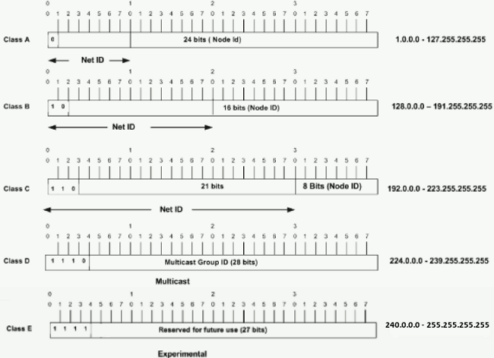

192.168.2.1/30

|  |  |  |
| --- | --- | --- |
| Network Address | 26 = | 64 |
| Host | 22-2 = | 2 |
| Block Size | 256-252 = | 4 |
| Subnet Mask | 255.255.255.252 |  |
|  |  |  |
| **Network** | **Host(IP)** | **BroadCast** |
| 192.168.2.2 | 192.168.2.2 | 192.168.2.4 |
|  | .... |  |
|  | .... |  |
|  | 192.168.2.3 |  |

192.168.90.1/27

|  |  |  |
| --- | --- | --- |
| Network Address | 23 = | 8 |
| Host | 25-2 = | 30 |
| Block Size | 256-224 = | 32 |
| Subnet Mask | 255.255.255.224 |  |
|  |  |  |
| **Network** | **Host(IP)** | **BroadCast** |
| 192.168.90.1 | 192.168.90.2 | 192.168.90.32 |
|  | .... |  |
|  | .... |  |
|  | 192.168.90.31 |  |

Router Configure

|  |
| --- |
| ** Same series of IP will be setup among two directly connected routers**  **Clock rate side is called DCE and another side is called DTE**  **Show the router interface ** Router#show ip interface brief  Router Mode:  Double click on router  router> *user mode  router>enable  router# *previllage mode  router#configure terminal  router(config)# *configuration mode  router(config)#interface serial 0/0  router(config-if) global cofiguration mode  Router configure:  router(config)#interface serial 0/0/0  router(config-if)# ip address 10.0.0.1 255.0.0.0  router(config-if)#clock rate 64000 *if DCE  router(config-if)#no shoutdown |

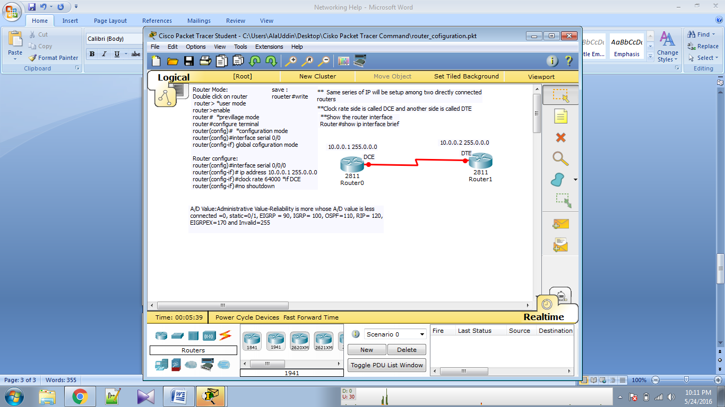

### RIPV-1 Routing([Routing Information Protocol](https://en.wikipedia.org/wiki/Routing_Information_Protocol))

|  |
| --- |
| Step1: configure all router as previous  Step2:  RIP-Configure on router0,router1,router2,router3  Router(config)#router rip  router(config-router)#network 10.0.0.0  #network 11.0.0.0  #network 12.0.0.0  #network 13.0.0.0  #exit  router#show ip route  **router1,router2,router3 network only one time  ** To delete ip (rip) routing  router(config)#no route rip |

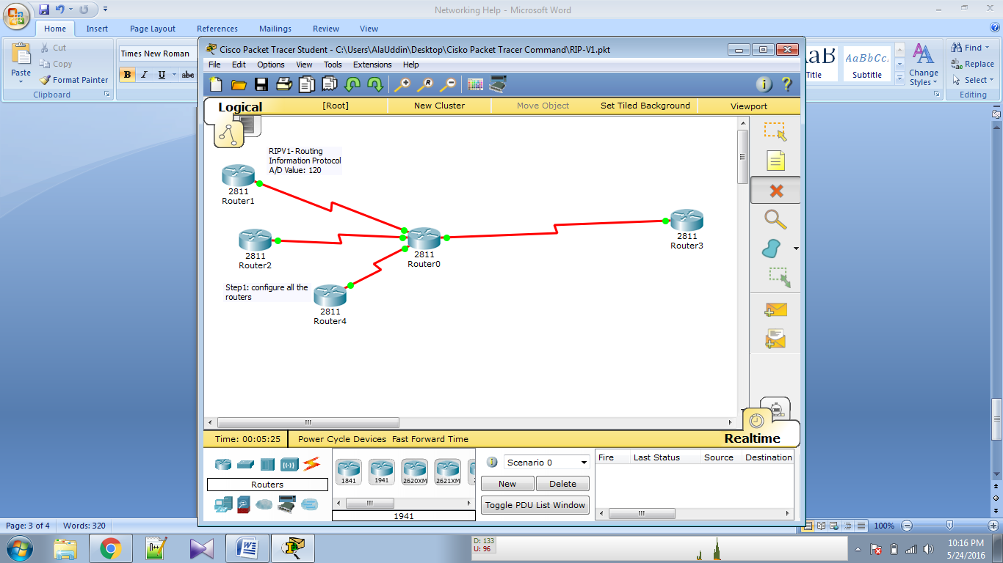

### RIPV-2 Routing([Routing Information Protocol](https://en.wikipedia.org/wiki/Routing_Information_Protocol))

|  |
| --- |
| RIP-V2  1. Hybrid routing protocol  2.based on RIP-V1  3.Multicast to disseminate routing  information 244.0.0.9  4.support triggred update (instantly)  5.support VLSM (Classless routing)  6. others are same as RIP-V1  Configuration:  Step1: configure all the routers  Step2:  Router(config)#router rip  router(config-router)#version 2  #network 10.0.0.0  do the same of all routers  exit  router#show ip route. |

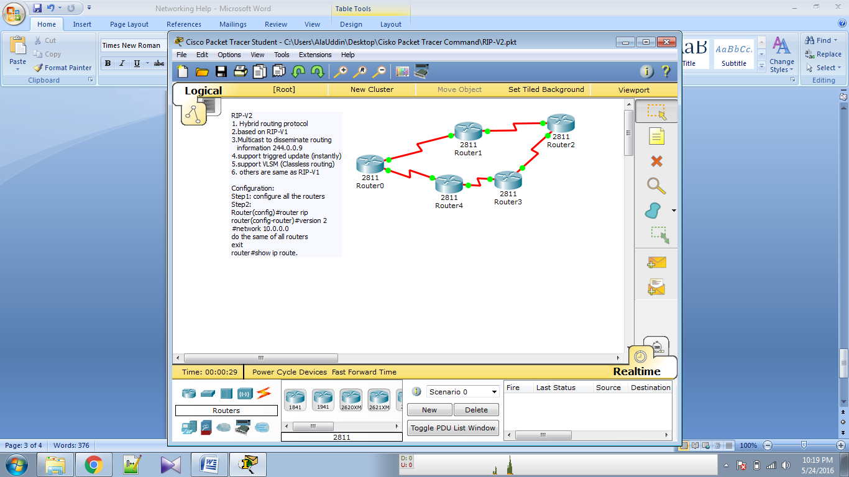

### DHCP Routing(Dynamic Host Configuration Protocol)

|  |
| --- |
| step1: Configure the router  Step2:  Router(config)#IP dhcp pool mypool  #network 11.0.0.0 255.0.0.0  #domain-name chl.com  #dns-server 11.0.0.1 11.0.0.2  #default-router 11.0.0.1  #lease 7  #exit  #ip dhcp excluded-address  11.0.0.1 11.0.0.50  #exit  Step3:  Cofigure PC. and ping  Router#show ip dhcp binding  If want to ping from Laptop0 to router1 and vice-varsa then  Step1:  RIPV1 Configure on  router0  Router(config)#router rip  Router(config-router)# network 10.0.0.0  Router(config-router)# network 11.0.0.0 |

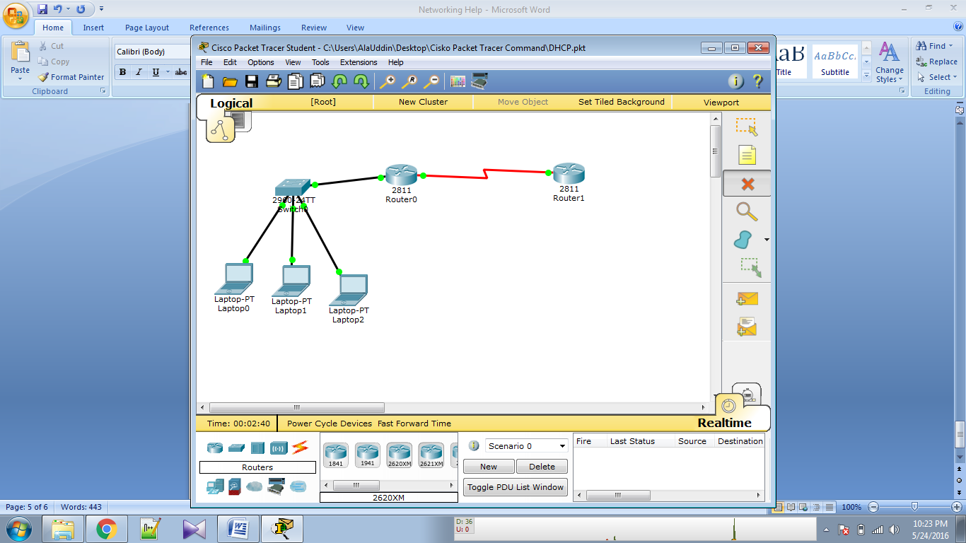

### Static Router

|  |
| --- |
| Static Router##  1. config all router.  2. router 0 to router 2 static kora  command ;  Router(Config)# ip route 11.0.0.0 255.0.0.0 10.0.0.2  R1 and R2 er nerwork address+ R1 and R2 er subnet mask +R0 and R1 er R1 panter ip address |

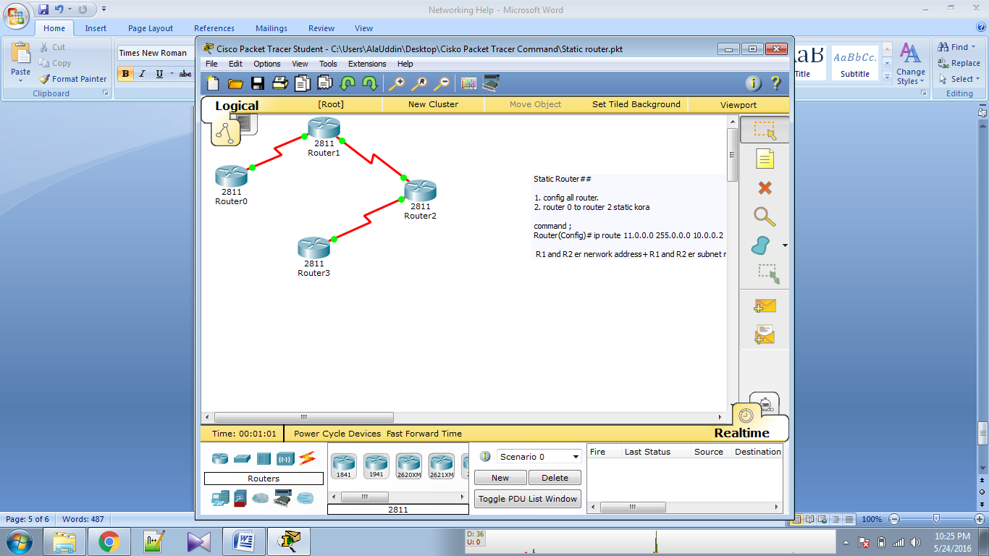

### Static Router

|  |
| --- |
| Static Router##  1. config all router.  2. router 0 to router 2 static kora  command ;  Router(Config)# ip route 11.0.0.0 255.0.0.0 10.0.0.2  R1 and R2 er nerwork address+ R1 and R2 er subnet mask +R0 and R1 er R1 panter ip address |